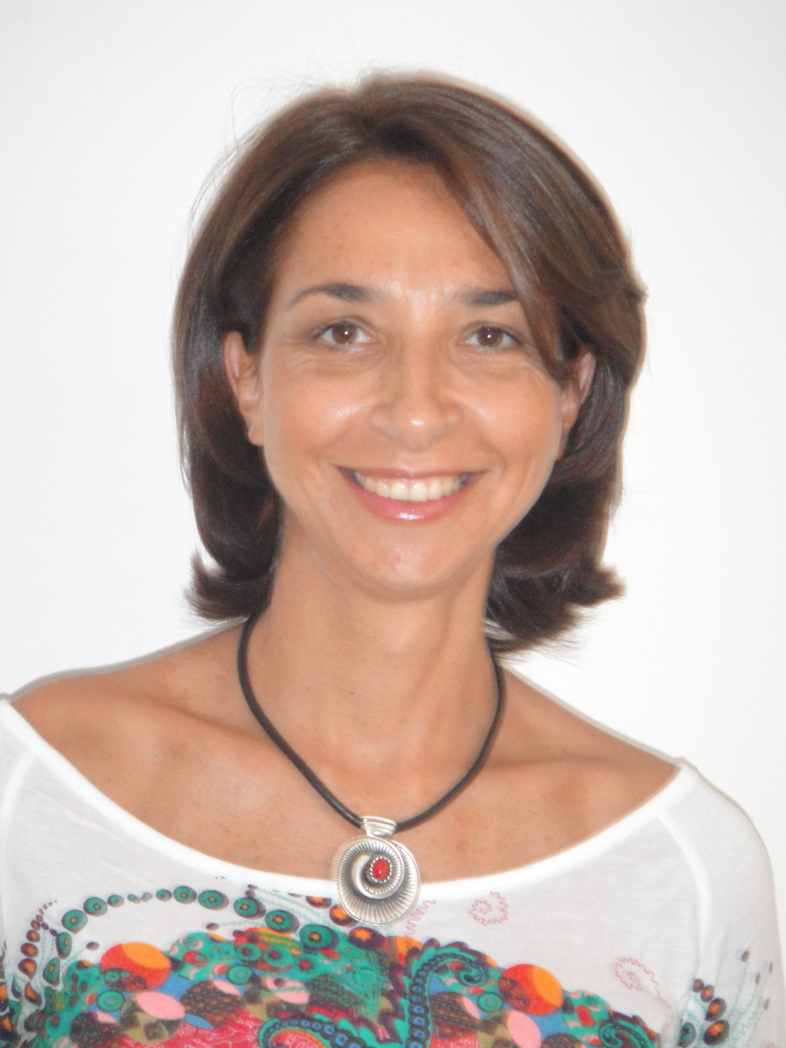

Bénédicte SEGUIN
DUBAI UAE
Tel: 00 971 56 75 95 180
E-mail: benedictseguin@yahoo.com
www.magnificence-coaching.com
39 years old, married,
French nationality

OBJECTIVE

To join an organization, where I can offer my project management skills, while adding value through my training and coaching experience to the team.

PROFESSIONAL EXPERIENCES

Executive Sept 2012 to date, Freelancer at Magnificence
Coach Specialized in Professional Self-Image & Leadership Development
Dubai • Executive Coaching
• Team training on communication and coaching skills to improve Team Communication, Synergy & Effectiveness in the premium industry

Personal Image Consultant  Cairo | Jan 2008 – Sept 2011, Freelancer  • Coaching and training on non-verbal communication skills to boost personal and professional image of individuals and corporates (personal appearance, behaviors, body language).

BOUYGUES TELECOM

Web marketing Project Manager  Paris | Jan 2001 - Sept 2006  • Communication plan of the customer company’s website.  • Managing projects and coordinating with third parties.
Communication Manager  Paris | Sept 99 - Jan 2001  ● Brochure and advertising designs for retailers.  ● Project Management of the prepaid mobile offer on the company’s website.  ● Promotion of events for the Nomad prepaid mobile offer.  ● Project Management and coordination with third parties.
Key Account Sales Manager  Paris | June 97 - Sept 99  ● Business development and definition of the sales offer for Key Accounts.  ● Implementation and involvement in a VIP Key Accounts Group.

RENTOKIL INITIAL

Key Account Sales Manager  Paris | Jan 96 – June 97  ● Introduction of a new range of products for companies: the electrostatic air cleaner system.  ● Definition of the sales offer for Civil Services Key Accounts.  Supplier for the Elysée Palace, Ministries and Town Halls.

EDUCATION

2013 • Currently attending the Leadership Program of Coaches Training Institute (CTI) – ICF Accredited

2012 • Certified Professional Co-active Coach (CPCC) from CTI
• Completed CTI Executive Workshop in London

• Associated Certified Coach (ACC) and member of the International Coach Federation (ICF)

2008 | • Certified Personal Image Consultant  AFFAIRES D’IMAGES Training Institute in Paris.
1995  1991 | • Graduate TRUDAINE, Business School of the Chamber of Commerce and Industry of Paris.  • Baccalauréat Lettres-Langues, mention Assez Bien (High School Diploma in Literature and Languages)

OTHERS

SPORTS | Running, Aqua aerobics, Yoga, Zumba, Walking.
VOLUNTEER SERVICES

American Hospital 2010/2011
Dubai • Assisting women diagnosed with breast cancer to enhance their personal image and boost self-esteem and confidence. To allow them to better achieve their personal and professional goals.

PERSONAL ASSIGNMENTS

Health Care • Improvement of Doctor – Patient Relationships

Education Providers • Helping graduates improve their communication and leadership skills for a better integration in the work place.

